- Docker
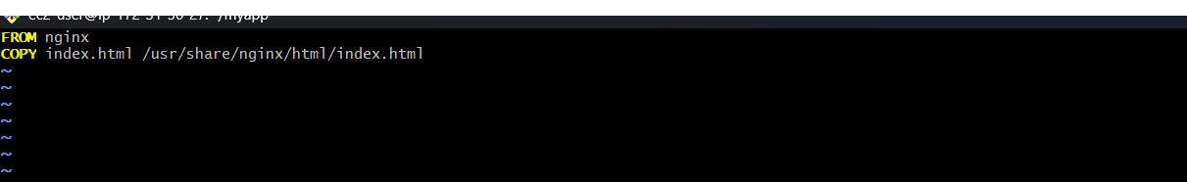
  - Create a Docker file
  - Run App using Docker container.
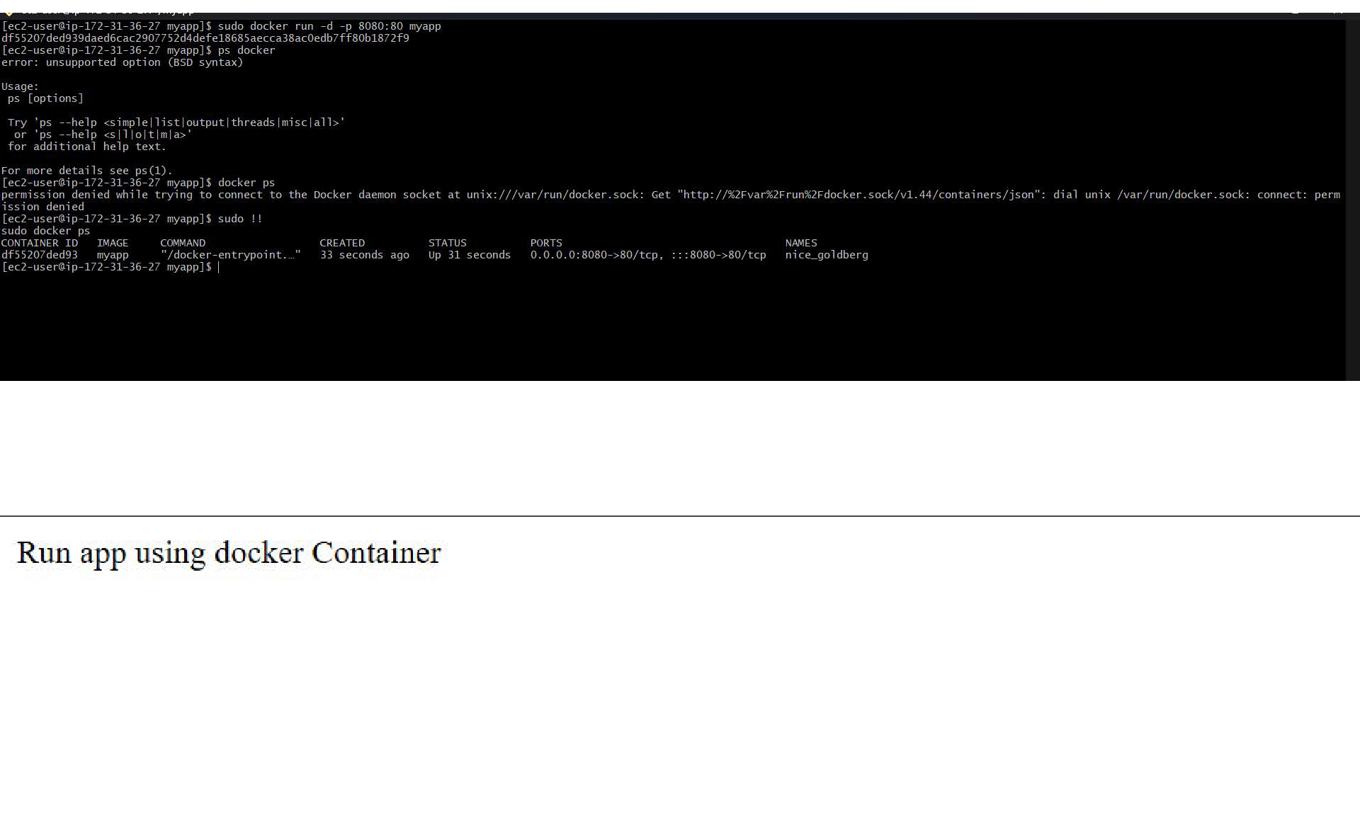
  - Expose required port
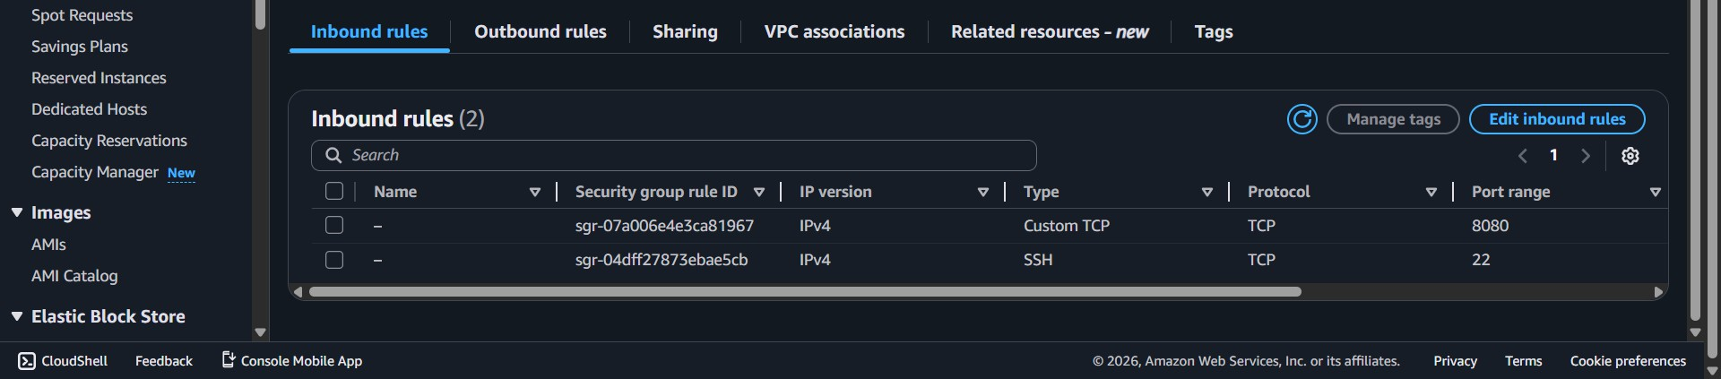

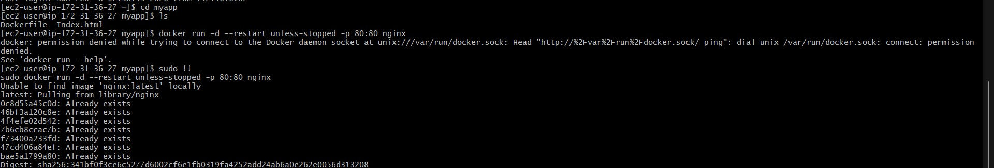
-Ensure containers aut

